Components that refuse to be cached in CacheView

Test Report
- Build Tested: .NET SDK 11.0.100-rc.1.26425.128; ASP.NET Core runtime 11.0.0-rc.1.26425.128
- Configurations tested: Static SSR
- Also exercised: None
- OS, Browser, IDE: Windows 11, Microsoft Edge, Visual Studio
- Sample app: BrundhaVelusamy/CacheViewRefusalValidation
- Outcome: Validation Passed

.NET SDK Detail:
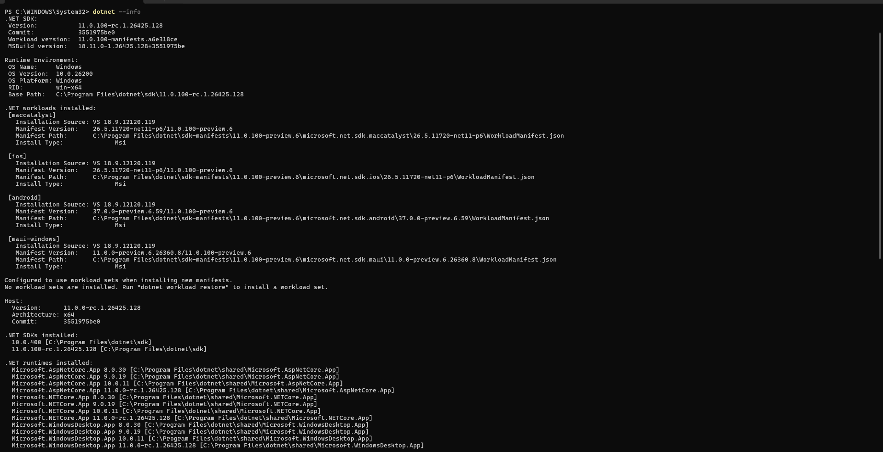

Repository Revision
Repository: BrundhaVelusamy/CacheViewRefusalValidation
Branch: main
Commit Tested: 31e0cd86ba4ab711c3daf4f24af080037e71604b
Validation Methodology
- This validation was performed manually through browser-based testing in Static SSR application.
- Each scenario was executed and verified using the evidence artifacts listed in the Evidence section.
- Repeatable comparison records were retained through:
  - Screenshots and video recordings
  - exception captures
  - cache ID comparisons
  - sorting output comparisons
Checks:
S No | Scenario | Test Status | Comments
1 | Launch CacheView validation sample application | Works Properly | Application loaded successfully and all validation pages were accessible.
2 | AuthorizeView inside CacheView without VaryByUser | Works Properly | InvalidOperationException was thrown. Error message identified AuthorizeView and instructed to configure VaryByUser or move the component outside the CacheView. Refer to AuthorizeView_Refusal.png for the complete exception message.
3 | AuthorizeView inside CacheView with VaryByUser | Works Properly | Page rendered successfully after adding VaryByUser. User-specific content was displayed correctly.
4 | QuickGrid inside CacheView without VaryByQuery | Works Properly | InvalidOperationException was thrown. Error message identified QuickGrid and instructed to configure VaryByQuery or move the component outside the CacheView. Refer to QuickGrid_Refusal.png for the complete exception message.
5 | QuickGrid inside CacheView with VaryByQuery="*" (* for all query parameters) configured | Works Properly | QuickGrid rendered successfully once query-based variation was configured.
6 | Sort QuickGrid column after configuring VaryByQuery | Works Properly | Sorting completed successfully and grid output reflected the selected sort order.
7 | UserBadge inside CacheView without vary-by configuration | Works Properly | InvalidOperationException was thrown. Error message identified UserBadge and instructed to move the component outside the CacheView. Refer to UserBadge_Refusal.png for the complete exception message.
8 | UserBadge inside CacheView with vary-by configuration | Works Properly | Component continued to throw InvalidOperationException even after applying user, query, and cookie-based vary-by settings, confirming unconditional cache refusal behavior. Refer to UserBadge_VaryByConfigured_Refusal.png for the complete exception message.
9 | UserBadge moved outside CacheView | Works Properly | Component rendered successfully when removed from the cache boundary.
10 | PricePanel inside CacheView without VaryByCookie | Works Properly | Cache entry remained stable while lifecycle-generated identifier changed on each refresh, confirming live rerendering behavior.
11 | PricePanel inside CacheView with VaryByCookie="price-selection" | Works Properly | Cache entry and lifecycle-generated identifier remained stable across refreshes, confirming cache reuse.
12 | Change price-selection cookie and reload cached page | Works Properly | A new cache entry was created for the different cookie value and rendered correctly and remained stable across refreshes, confirming cache reuse.
13 | Nested CacheView validation | Works Properly | InvalidOperationException was thrown indicating that nested CacheView components are not supported. Refer to NestedCacheView_Refusal.png for the complete exception message.
14 | Review refusal and validation error messages | Works Properly | All error messages clearly identified the component, explained the reason for failure, and provided actionable guidance without requiring source-code inspection.

Evidence
Scenario | Evidence
AuthorizeView refusal without VaryByUser | AuthorizeView_Refusal.png
AuthorizeView renders with VaryByUser | AuthorizeView_VaryByUser_Fixed.mp4
QuickGrid refusal without VaryByQuery | QuickGrid_Refusal.png
QuickGrid renders with VaryByQuery | QuickGrid_RendersWithVaryByQuery.png
QuickGrid sorts with VaryByQuery | QuickGrid_SortOutputChangesCorrectly.mp4
UserBadge refusal without vary-by | UserBadge_Refusal.png
UserBadge refusal with vary-by configured | UserBadge_VaryByConfigured_Refusal.png
UserBadge rendered outside CacheView | UserBadge_MovedOutsideCacheView_Fixed.png
PricePanel without vary-by-cookie | PricePanel_LiveRendering_Without_Vary-by-cookie_Configured.png
PricePanel live render behavior | PricePanel_LiveRendering.mp4
PricePanel cached with cookie variation | PricePanel_VaryByCookie_Cached.mp4
Nested CacheView not supported | NestedCacheView_Refusal.png

Exception Message and its Usability Assessment
Component | Assessment | Exception
AuthorizeView | The exception clearly identified AuthorizeView and instructed the developer to configure VaryByUser or move the component outside the CacheView. No source-code inspection was required. | InvalidOperationException: Component 'Microsoft.AspNetCore.Components.Authorization.AuthorizeView' cannot be used inside a CacheView because its output depends on per-request state ([CacheBehavior(CacheBehavior.Throw)], [CacheCondition(CacheVaryBy.User)]) that cannot be safely cached and replayed. To fix this, configure the CacheView to vary by User, or move the component outside the CacheView.
QuickGrid | The exception clearly identified QuickGrid and instructed the developer to configure VaryByQuery or move the component outside the CacheView. No source-code inspection was required. | InvalidOperationException: Component 'Microsoft.AspNetCore.Components.QuickGrid.QuickGrid`1[[CacheViewValidationSSR.Components.Pages.QuickGridRefusal+Product, CacheViewValidationSSR, Version=1.0.0.0, Culture=neutral, PublicKeyToken=null]]' cannot be used inside a CacheView because its output depends on per-request state ([CacheBehavior(CacheBehavior.Throw)], [CacheCondition(CacheVaryBy.Query)]) that cannot be safely cached and replayed. To fix this, configure the CacheView to vary by Query, or move the component outside the CacheView.
UserBadge | The exception clearly identified UserBadge and instructed the developer to move the component outside the CacheView. Since the component declared CacheBehavior.Throw, the message provided sufficient guidance without source inspection. | InvalidOperationException: Component 'CacheViewValidationComponents.Components.UserBadge' cannot be used inside a CacheView because its output depends on per-request state ([CacheBehavior(CacheBehavior.Throw)]) that cannot be safely cached and replayed. To fix this, move the component outside the CacheView.
Nested CacheView | The exception explicitly stated that CacheView cannot be nested and instructed the developer to move the inner CacheView. No source-code inspection was required. | InvalidOperationException: A CacheView cannot be nested inside another CacheView. The inner CacheView's output would be frozen into the outer cache entry and replayed on later requests, which is unsafe for per-request content such as antiforgery tokens, authentication-dependent output, or interactive component markers. Move the CacheView so it is not nested inside another one.

QuickGrid sorting
Initial URL: http://localhost:5054/quickgrid/fixed
Initial Order:
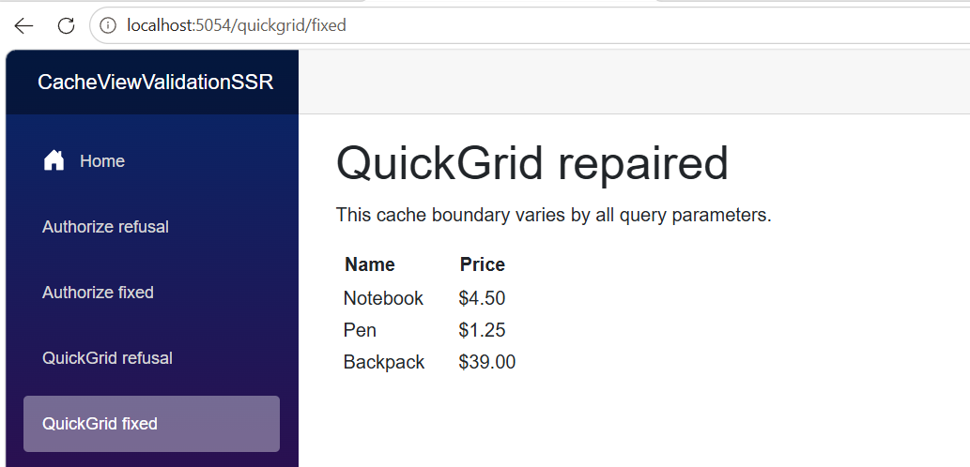
Sorted URL: http://localhost:5054/quickgrid/fixed?sort=Name&direction=desc
Sorted Order:
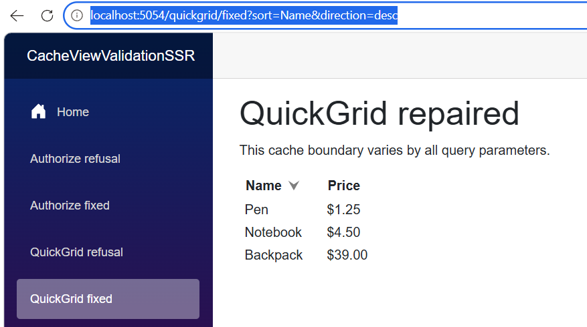
PricePanel comparisons
Configuration | Request | Cookie Value | Cache-entry ID | Lifecycle ID | Comparison | Result
Live (No VaryByCookie) | 1 (Cold) | standard | 83797d36-f45c-4e0f-8059-af0f36cca5b0 | b162f97e-e86f-42b8-9c17-6d4f1f19c504 | Baseline request. Cache entry and lifecycle identifiers are recorded. | Initial render
Live (No VaryByCookie) | 2 (Refresh) | standard | 83797d36-f45c-4e0f-8059-af0f36cca5b0 | 2e56b30f-8de4-4efb-bc2c-299387ab914c | Cache-entry ID remains the same, Lifecycle ID changes. | Pass (Confirms live re-rendering within cached section.)
Cached (VaryByCookie="price-selection") | 1 (Cold) | standard | b8c30184-eca3-4a1d-a6d3-28d6681d216d | addb71a7-07ca-4f27-a00a-200c0ff2fbf6 | Baseline request for standard pricing cache entry. | Initial render
Cached (VaryByCookie="price-selection") | 2 (Refresh) | standard | b8c30184-eca3-4a1d-a6d3-28d6681d216d | addb71a7-07ca-4f27-a00a-200c0ff2fbf6 | Cache-entry ID remains the same, Lifecycle ID remains the same. | Pass (Confirms cache reuse.)
Cached (VaryByCookie="price-selection") | 3 (Cold) | premium | d6b0171c-bf14-4dd7-a3db-cdfc6b5f5358 | 7b58e81c-d10a-42d4-b56d-b0eb667ddadb | New cookie value produces a different cache entry and lifecycle identifier. | Pass (Confirms a distinct cache entry is created per cookie value.)
Cached (VaryByCookie="price-selection") | 4 (Refresh) | premium | d6b0171c-bf14-4dd7-a3db-cdfc6b5f5358 | 7b58e81c-d10a-42d4-b56d-b0eb667ddadb | Cache-entry ID remains the same, Lifecycle ID remains the same. | Pass (Confirms cached premium entry reuse.)

Documentation Assessment
Reviewed Documentation: ASP.NET Core Blazor CacheView component | Microsoft Learn
Observations:
- The documentation explains CacheView concepts, cache boundaries, vary-by options, expiration settings, and limitations.
- It provides sufficient information to understand why AuthorizeView requires VaryByUser, why QuickGrid requires VaryByQuery, and why cookie-dependent output should use VaryByCookie.
- It provides basic examples of CacheBehavior.Throw, CacheBehavior.Rerender, and CacheCondition, including a user-based conditional safety example.
- However, it doesn't provide comprehensive guidance for third-party component authors, such as a behavior matrix explaining when to use unconditional refusal, conditional refusal, rerendering, or conditional caching.
- It doesn't explicitly demonstrate scenarios equivalent to an unconditional UserBadge refusal or a PricePanel that rerenders unless a cookie vary-by condition is satisfied.
- It also doesn't show representative actionable exception messages or clearly document named conditions and how multiple conditions are evaluated.
Documentation Sufficiency Verdict: Partially Sufficient
The documentation provides solid foundational CacheView guidance and basic component-author declarations. However, it doesn't fully cover third-party component-authoring patterns, conditional rerender and caching behavior, unconditional refusal scenarios, or the actionable exception-message expectations validated by this issue.

Build Result
- Build completed successfully.
- Errors: 0
- Build Warnings: 0
- Runtime warnings: 1
  - During execution, one runtime warning was observed in Static SSR sample application:
Microsoft.AspNetCore.HttpsPolicy.HttpsRedirectionMiddleware[3]
Failed to determine the https port for redirect.
  - This warning is unrelated to this validation.
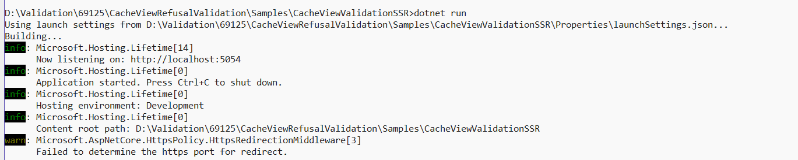

Unexpected Behavior
No unexpected CacheView behavior was observed during validation. All scenarios behaved as described in the issue requirements and documentation.

Configuration Differences
Static SSR was the only supported configuration required for this validation. No configuration-specific differences were observed, and no additional render modes were applicable to this scenario.

Not Covered: None of the required checks or configurations were omitted.

